**LIFEBRIDGE INTEGRATEDLEARNING CENTRE**

**GRADE 8 GEOGRAPHY URBANISATION**

**SOCIAL ISSUES RELATED TO THE RAPID GROWTH OF CITIES**

**Name:__________________________________**

Study the evidence below and answer the questions that follow:

1. In 1995 when the newly elected South African government launched its Reconstruction and Development Plan (RDP) it was calculated that about 250000 houses per year needed to be built to provide basic housing for the many people living in shanty towns and informal settlements. However in the following five years only about 25000 houses were built every year.

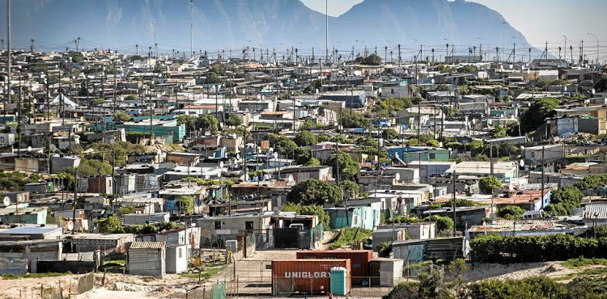

C.

1. 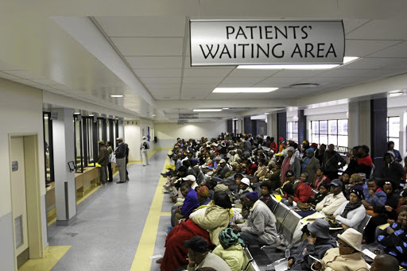
2. 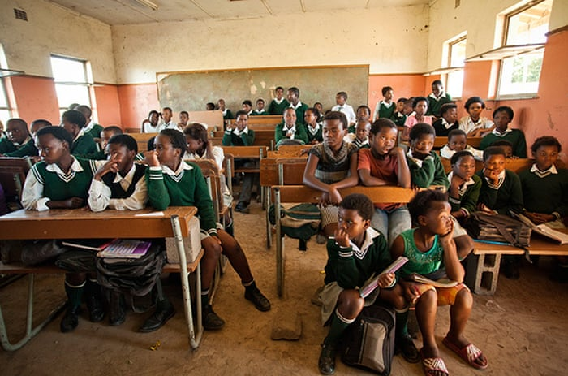

**QUESTIONS**

1. Even if the number of homeless people were not increasing how big would the housing backlog be by 2000 according to the figures in source A?

|  |
| --- |
|  |

1. What is an informal settlement?

|  |
| --- |
|  |

1. Describe three serious challenges that face people living in informal settlements?

|  |
| --- |
|  |
|  |
|  |

1. Why do you think there has been such a rapid increase in informal settlements in South African cities?

|  |
| --- |
|  |

1. What problems are associated with providing health care to the many poorer people in South Africa?

|  |
| --- |
|  |

1. Describe two difficulties you would have being a student in the type of classroom pictured in source D

|  |
| --- |
|  |
|  |

1. Discuss and identify three possible effective solutions to some of the problems associated with the rapid growth of cities.

|  |
| --- |
|  |
|  |
|  |