**THE WOMEN’S MOVEMENT OF 1960’S AND 1970’S (SECOND WAVE FEMINISM)**

**GRADE 12 HISTORY**

1. **CONTEXT – THE BABY BOOMER GENERATION**
   1. **How did WW2 affect the way women saw themselves and their part in society?**

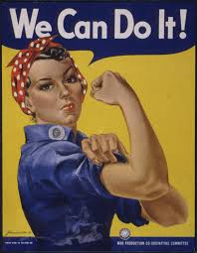

What does this poster from WW2 suggest about the power and ability of women?

How does it position women in relation to men?

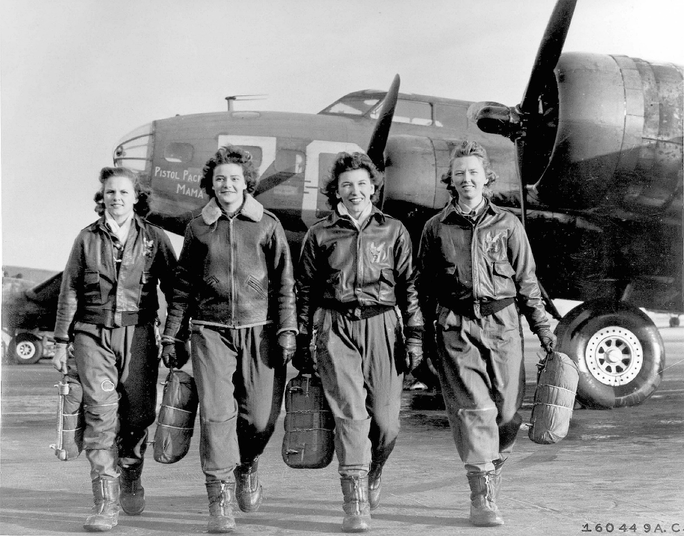

This WW 2 photograph shows women who played an active part in the US Air Force. How easy would it have been for these women to adjust to being stay-at-home housewives and mothers under the authority of their husbands after the war? Why could their wartime experiences possibly affect their views on the rights of women?

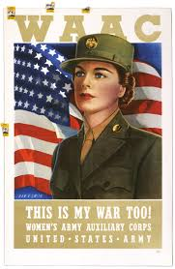

The wartime US recruiting poster may have influenced the way women came to view their place in society. Explain this.

* 1. **USA came out of the war wealthy and strong – how did this influence the way people lived? How did that change the position and role of women?**

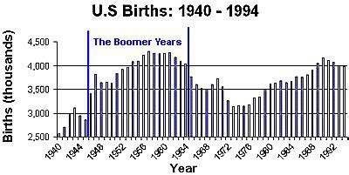

There was a sudden increase in the birth rate after WW2. What doe you think caused this and how did it possibly influence the status of women?



Name three aspects of the ideal American lifestyle portrayed in this advertisement. How did this set the stage for women to want to change their role and status?

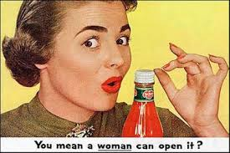

How does this advertisement for a new ketchup bottle from the late 1950s portray women and why would it not be possible to use this advertisement today?

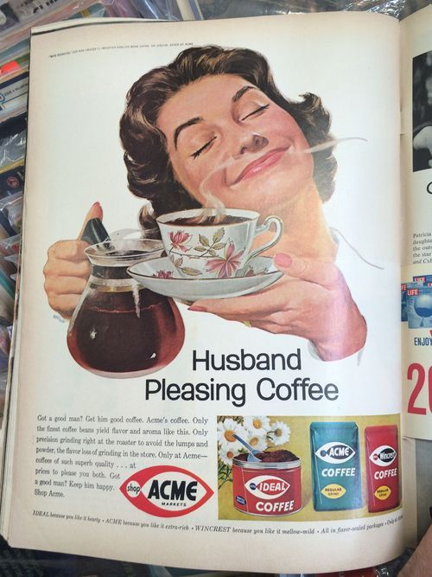

What stereotype regarding the role of women in relation to men is being portrayed in this 1950s magazine advertisement and how did views like this influence women to want to make changes.

* 1. **This was the era of the Cold War – How did that influence women’s status**

In the extract from an American propaganda comic from the 1960s the role of the women is put forward in a very clear and particular way.

Briefly describe what the ideal role and purpose of women was seen as and explain how attempts to challenge that role were politicised by the Cold War.

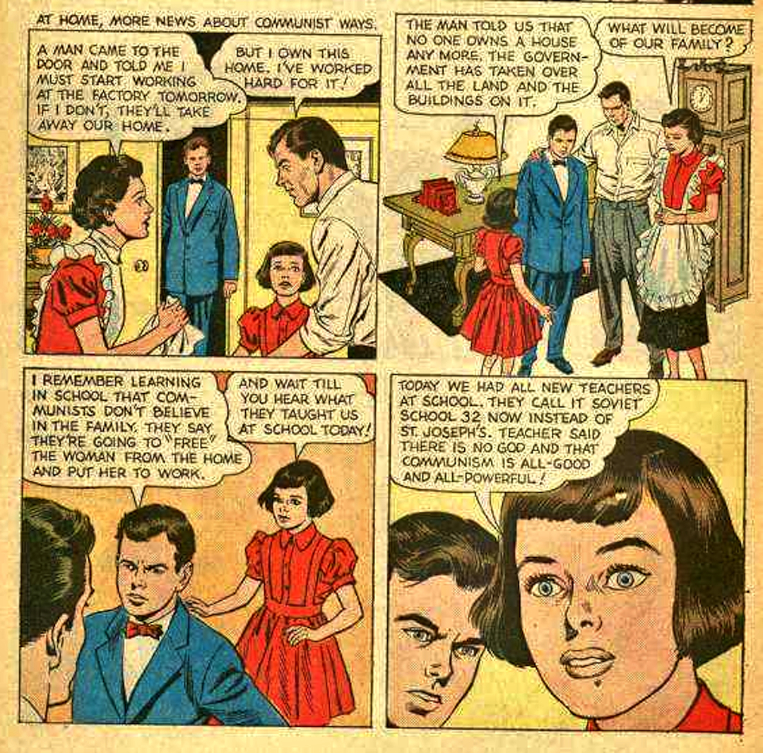

1. **THE TRADITIONAL ROLE AND IMAGE OF WOMEN IN AMERICA**
   1. **What were the three important life roles all girls were prepared for?**

Little Boxes

By [Malvina Reynolds](https://www.google.com/search?sxsrf=ALeKk01RW9bqz_RLPezNGrvIF42IRJ7SBQ:1595323684410&q=Malvina+Reynolds&stick=H4sIAAAAAAAAAONgVuLUz9U3MDU0yqtaxCrgm5hTlpmXqBCUWpmXn5NSDABxmuUTIAAAAA&sa=X&ved=2ahUKEwjo6orsg97qAhU6QhUIHUyGBuYQMTAAegQIDxAF)

Little boxes on the hillside  
Little boxes made of ticky-tacky  
Little boxes on the hillside  
Little boxes all the same  
There's a green one and a pink one  
And a blue one and a yellow one  
And they're all made out of ticky-tacky  
And they all look just the same

And the people in the houses  
All went to the university  
Where they were put in boxes  
And they came out all the same  
And there's doctors and lawyers  
And business executives  
And they're all made out of ticky-tacky  
And they all look just the same

And they all play on the golf course  
And drink their martinis dry  
And they all have pretty children  
And the children go to school  
And the children go to summer camp  
And then to the university  
Where they are put in boxes  
And they come out all the same

And the boys go into business  
And marry and raise a family  
In boxes made of ticky-tacky  
And they all look just the same  
There's a pink one and a green one  
And a blue one and a yellow one  
And they're all made out of ticky-tacky  
And they all look just the same

Source: [LyricFind](https://www.lyricfind.com/)

Little Boxes lyrics © O/B/O Capasso

**(**You can watch this song being performed at<https://www.youtube.com/watch?v=VUoXtddNPAM>)

How does this song, written and released in 1962, sum up the typical middles class American image of family life?

Read the article in the link below and watch the video that it includes:

<https://www.historycentral.com/sixty/Americans/WOMEN.html>

* 1. **Why were employers reluctant to advance women to senior positions?**
* Males were supposed to be the primary breadwinners – giving women “men’s jobs” was seen as potentially robbing families and children of income.
* Women could fall pregnant and lose work time.
* It was assumed that men would not be happy to take orders from women.
* It was feared women would be a distraction to their male colleagues.
* It was believed that there were a number of tasks that men just did better than women, because they thought differently.

Can you construct counter-arguments for each of these five statements and state the counter arguments in five sentences (one sentence each.)

1. **HOW WOMEN WERE SUBJECTED TO DISCRIMINATION**

Read the interesting article at the following link: <https://edition.cnn.com/2014/08/07/living/sixties-women-5-things/index.html>

Identify one form of discrimination against women from the 1960s that no longer applies today and explain why it has been rejected.

1. **FACTORS THAT DROVE CHANGE**
   1. **Related political movements**

How did the Civil Rights Movement and the anti-war protests against Vietnam inspire the struggle for women’s rights?

* 1. **New ideas – books**

Name three writers and their books, and briefly sum up the contribution of each in inspiring the rise of the Women’s Movement.

* 1. **Technology**

The following new inventions became widely available for the first time in the late 1950s or early 1960s. Explain briefly how each one influenced the shift in the way women felt about their roles and rights:

* Automatic dishwashers
* Vacuum cleaners
* Television sets

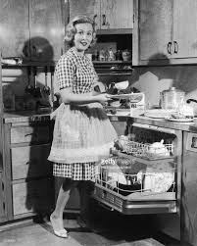

* 1. **The Pill**

The first oral contraceptive was patented and put on the market in 1957 but it took several years before it was readily and easily available for most women. Explain why it changed the way women could function in society and how it contributed to the drive for greater freedom for women. What were some of the possible negative effects of the pill and do these outweigh the positive benefits or not? Explain the reasons for your opinion.

1. **RESISTANCE TO CHANGE**

Suggest why the following groups would have resisted the changes that the women’s movement sought?

* Male employers and men in the workplace
* Conservative and Christian groups
* The fashion, advertising and entertainment industries
* The government and law enforcement agencies such as the FBI

Describe briefly some ways in which resistance to women’s rights was encountered by women in the 1960s.

1. **GAINS OF THE WOMEN’S MOVEMENT**

The following extract lists three successes in the 1960s and 70s of the Women’s Movement

Source: <https://www.rightathome.net/blog/womens-movement-successes-of-past-three-centuries>

##### **1963: Congress Passes the Equal Pay Act**

President John F. Kennedy appointed Eleanor Roosevelt chairwoman of the President’s Commission on the Status of Women in 1961, and a report published by the commission in 1963 found “substantial discrimination against women in the workplace.” As a result, Congress passed the Equal Pay Act, aimed at eradicating the pay gap between men and women.

##### **1972: Title IX Brings Equal Opportunity to Education**

Title IX, now known as the Patsy Mink Equal Opportunity in Education Act, was authored by Senator Birch Bayh of Indiana. It brought greater educational opportunities to women. The 1964 Civil Rights Act included gender equality, but it left out public education. Title IX had an especially significant impact on American sports because it required high schools and colleges to provide equal opportunities for female athletes. The landmark legislation is credited with greatly increasing the participation of young women in sports.

##### **2013: Ban on Women in Combat Is Lifted**

Defense Secretary Leon Panetta petitioned the Joint Chiefs of Staff to reverse a 1994 rule that prevented women from serving in combat. The result? An announcement from Chairman Gen. Martin Dempsey that said, “The time has come to rescind the direct combat exclusion rule for women and to eliminate all unnecessary gender-based barriers to service.”

1. Decide whether you believe these are significant successes or not and briefly give reasons for your view.
2. Discuss any other single benefit gained in America by the Women’s movement.
3. **LEGACY OF THE WOMEN’S MOVEMENT TODAY**

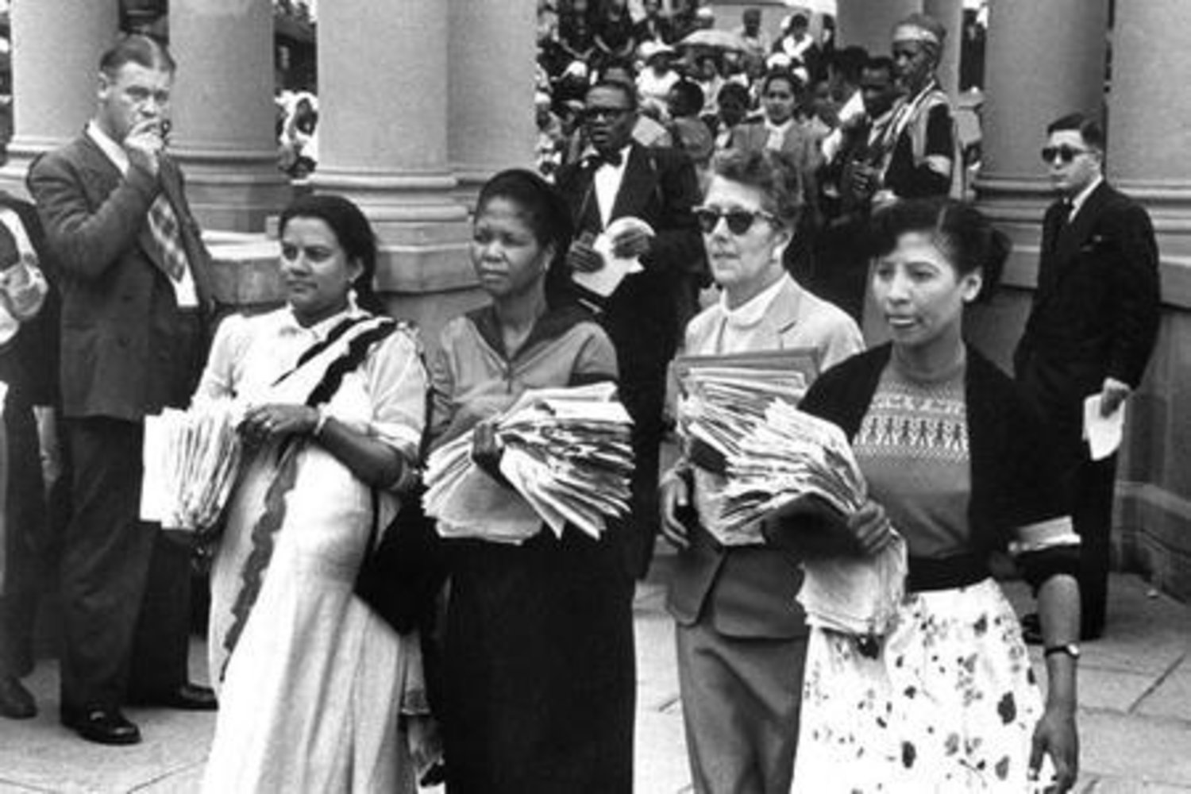

These photographs were taken on 9 August 1956at the Union Buildings when Women Marched in protest against pass laws.

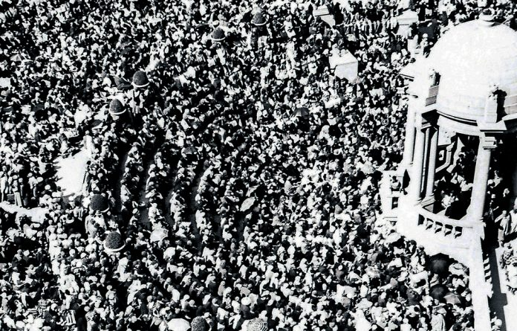

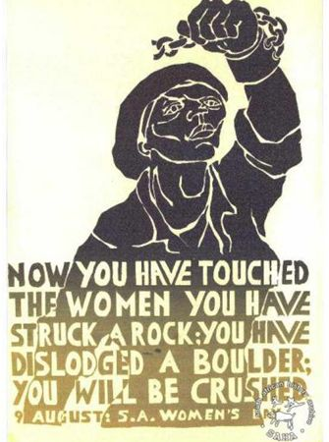

Discuss how women played a role in the South African liberation struggle and how this was linked to the struggle for women’s rights.

How does the struggle for women’s rights still have relevance in South Africa and in other parts of the world today? Identify and very briefly describe three important issues that women’s movements focus on now:

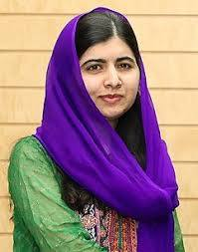 Malala Yousafzai

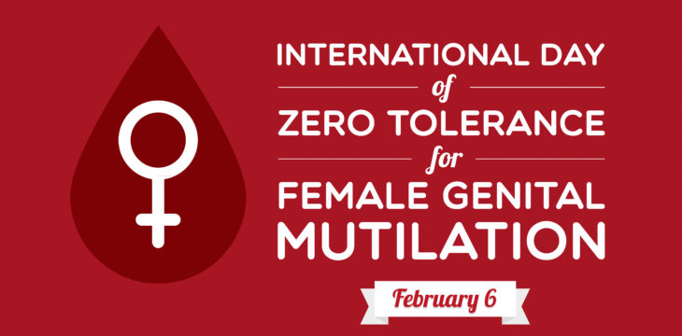

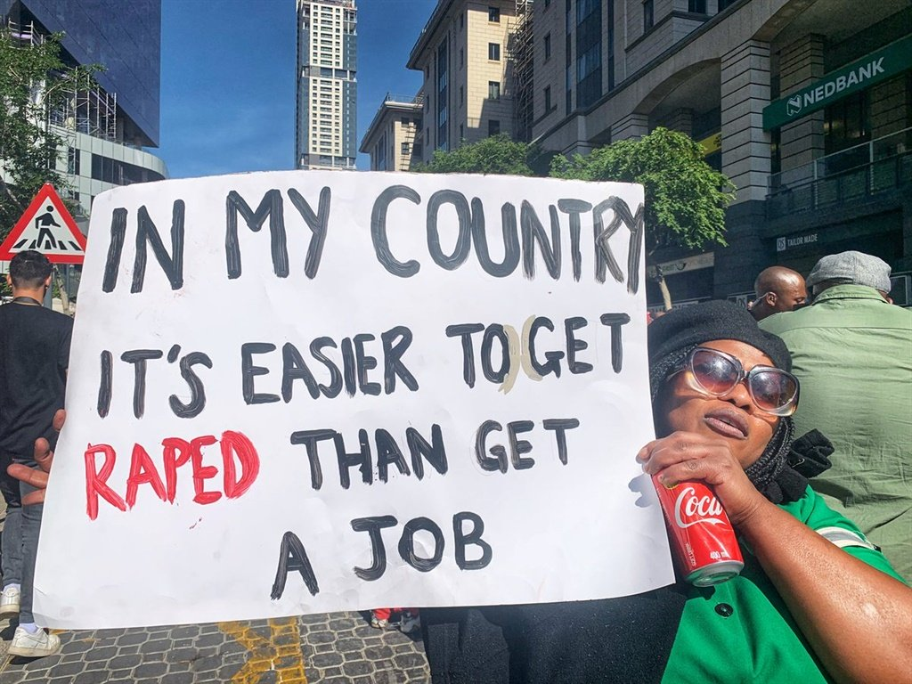

1. **GENERAL OVERVIEW RESOURCES**

The following two sites are extremely important for a broad overview of this subject and are relevant to all aspects. The articles must be carefully studied.

<https://www.khanacademy.org/humanities/us-history/postwarera/1960s-america/a/second-wave-feminism>

<https://tavaana.org/en/case-studies/1960s-70s-american-feminist-movement-breaking-down-barriers-women>